Create the following queries using the Chinook Database.

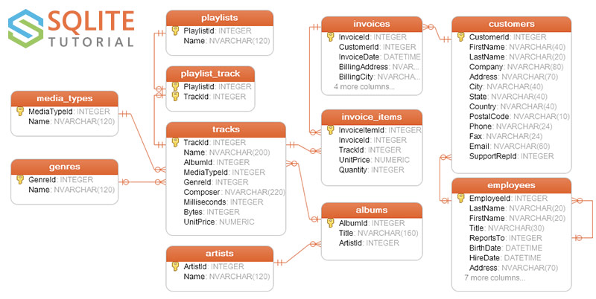

PRIMERA PARTE

1. Muestra los clientes de brasil*

SELECT *

FROM customers

WHERE Country == 'Brazil';

1. Muestrame los empleados que son agentes de ventas*

SELECT *

FROM employees-- WHERE Title == 'Sales Support Agent';

WHERE title LIKE 'Sales%';

1. Muestrame las canciones de ‘AC/DC’

SELECT *

FROM tracks

WHERE composer == 'AC/DC';

1. Muestra los clientes que no sean de USA: Nombre completo, ID, Pais*

SELECT FirstName || ' ' || LastName AS ‘Nombre completo’,

CustomerId,

Country

FROM customers

WHERE country != 'USA';

1. Muestrame los empleados que son agentes de ventas: Nombre completo, Dirección (Ciudad, Estado, Pais) y email

SELECT FirstName || ' ' || LastName as 'Nombre completo',

City || ',' || State || ',' || Country as 'Direcion',

Email

FROM employees

WHERE title LIKE 'Sales%';

1. Muestra una lista con los paises que aparecen a los que se ha facturado, la lista no debe contener paises repetidos*

SELECT DISTINCT Country

FROM customers;

1. Muestra una lista con los estados de USA de donde son los clientes, la lista no debe contener estados repetidos

SELECT DISTINCT State

FROM customers

WHERE country == 'USA';

1. Cuantos articulos tiene la factura 37*

SELECT COUNT(invoiceid)

FROM invoice_items

WHERE invoiceid == 37;

1. Cuantas canciones tiene ‘AC/DC’

SELECT count(Name) as ‘canciones de ACDC’

FROM tracks

WHERE composer == 'AC/DC';

1. Cuantos articulos tiene cada factura*

SELECT invoiceid,

count(invoiceid) AS numElems

FROM invoice_items

GROUP BY invoiceid;

1. Muestrame cuantos facturas hay de cada pais

SELECT BillingCountry,

count( * ) as 'Facturas por pais'

FROM invoices

GROUP BY BillingCountry;

1. Muestrame cuantos items tiene cada factura

SELECT invoiceid,

count( * ) as 'Items por factura'

FROM invoice_items

GROUP BY invoiceid;

1. Cuantas facturas ha habido en 2009 y 2011*

SELECT strftime('%Y', InvoiceDate) AS anio,

count( * ) AS 'Facturas en 2009 o 2011'

FROM invoices

WHERE anio == '2009' OR

anio == '2011'

GROUP BY anio;

1. Cuantas facturas ha habido entre 2009 y 2011*

SELECT strftime('%Y', InvoiceDate) AS anio,

count( * ) AS 'Facturas'

FROM invoices

WHERE anio BETWEEN '2009' AND '2011'

GROUP BY anio;

1. Cuantos clientes hay de españa y de Brazil

SELECT count( * ) as clientes,

Country

FROM customers

WHERE Country == 'Spain' OR

Country == 'Brazil'

GROUP BY Country;

1. Muestrame las canciones que su titulo empieza por ‘You’

SELECT *

FROM tracks

WHERE name LIKE 'You%';

SEGUNDA PARTE

1. Facturas de Clientes de Brasil, Nombre del cliente, Id de factura, fecha de la factura y el pais de la factura*

SELECT c.firstName,

i.invoiceid,

i.InvoiceDate,

i.billingcountry

FROM customers c,

invoices i

WHERE c.customerid == i.customerid AND

c.country == 'Brazil';

O CON UN JOIN, mejor:

SELECT c.firstName,

i.invoiceid,

i.InvoiceDate,

i.billingcountry

FROM customers c

JOIN

invoices i ON c.customerid == i.customerid

WHERE c.country == 'Brazil';

1. Facturas de Clientes de Brasil*

SELECT i.*

FROM customers c

JOIN

invoices i ON c.customerid == i.customerid

WHERE c.country == 'Brazil';

1. Muestra cada factura asociada a cada agente de ventas con su nombre completo*

SELECT i.InvoiceId, e.FirstName || ' ' || e.LastName as 'Agente de ventas'

FROM employees e

JOIN

customers c ON e.Employeeid == c.supportRepId

JOIN

invoices i ON i.customerId == c.customerid

GROUP BY e.employeeId

1. Muestra el nombre del cliente, el pais, el nombre del agente y el total

SELECT c.FirstName || ' ' || c.LastName as Cliente, c.Country, e.FirstName || ' ' || e.LastName as 'Agente de ventas', i.Total

FROM employees e

JOIN

customers c ON e.Employeeid == c.supportRepId

JOIN

invoices i ON c.customerId == i.customerId

1. Muestra cada articulo de la factura con el nombre de la cancion

SELECT i.InvoiceId, t.Name

FROM tracks t

JOIN

invoice_items ii ON t.TrackId == ii.trackid

1. Muestra todas las canciones con su nombre, formato, album y genero

SELECT t.Name, f.Name as Formato, a.Title, g.Name as Genero

FROM tracks t

JOIN

genres g ON t.genreId == g.genreid

JOIN

media_types f ON f.mediatypeid == t.mediatypeid

JOIN

albums a ON a.albumid == t.albumid

1. Muestra cuantas canciones hay en cada playlist y el nombre de cada playlist

SELECT count(*) as Canciones, p.name as Playlist, p.playlistid

FROM playlist_track pt

JOIN

playlists p ON p.playlistid == pt.playlistid

group by p.playlistid

1. Muestra cuánto ha vendido cada empleado

SELECT ROUND(SUM(i.total)), e.EmployeeId as Empleado

FROM employees e

JOIN

customers c ON c.SupportRepId == e.EmployeeId

JOIN

invoices i ON c.CustomerId == i.CustomerId

GROUP BY e.employeeid

1. Quien ha sido el agente de ventas que más ha vendido en 2009?

SELECT round(sum(i.total)) as Ventas, e.EmployeeId as Empleado

FROM employees e

JOIN

customers c ON c.SupportRepId == e.EmployeeId

JOIN

invoices i ON c.CustomerId == i.CustomerId

where i.invoiceDate LIKE '%2009%'

GROUP BY e.employeeid

ORDER BY Ventas DESC

LIMIT 1

1. ¿Cuáles son los 3 grupos que más han vendido?

SELECT art.Name,

sum(ii.quantity) AS Ventas

FROM artists art

JOIN

albums alb ON art.artistid == alb.ArtistId

JOIN

tracks t ON t.AlbumId == alb.AlbumId

JOIN

invoice_items ii ON ii.TrackId == t.trackid

GROUP BY art.ArtistId

ORDER BY Ventas DESC

LIMIT 3;